Government of India
Ministry of Earth Sciences
India Meteorological Department Meteorological Centre, RS/RW Building, Airport, Ahmedabad-382 475. Phone and Fax : 079-22865449 E_ mail: metahm01@gmail.com
mcahm@rediffmail.com
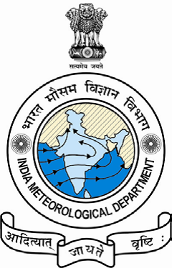
भारत सरकार
पृथ्वी विज्ञान मंत्रालय
भारत मौसम विज्ञान विभाग
पता : मौसम केंद्र,
आर एस/आर डब्‍लयु भवन,
हवाई अड्डा, अहमदाबाद-382,475
फोन न. 079 22865012

Port Warning No-02

Date and Time of issue: 15-12-2022 at 1300 Hrs IST
Sub: Deep Depression over Eastcentral and adjoining Southeast Arabian Sea.

Deep Depression over Eastcentral and adjoining Southeast Arabian Sea moved west northwestwards with a speed of 09 kmph during past 06 hours and lay centred at 0830 hrs IST of today, the 15th December 2022 over Eastcentral Arabian Sea near latitude 13.9°N and longitude 67.8°E about 620 km west northwest of Aminidivi (Lakshadweep), about 670 km west southwest of Panjim (Goa) and 1510 km east southeast of Salalah (Oman). It is very likely to move nearly westwards over central Arabian Sea away from Indian coast, maintain intensity of deep depression till early hours of tomorrow and weaken gradually thereafter.

SIGNAL:-
KEEP HOISTED SIGNAL DISTANT CAUTIONARY I (DC I) AT ALL PORTS OF NORTH AND SOUTH GUJARAT COASTS.
Warnings:-
FISHERMEN WARNING FOR NEXT 5 DAYS, FROM 15TH DECEMBER 2022 to 19TH DECEMBER 2022:
Fishermen warning for North Gujarat coast (Jakhau, Mandvi(Kutch), Mundra, New Kandla, Navlakhi, Jamnagar, Salaya, Okha, Porbandar)-NIL
DAY 1- NIL
DAY 2- NIL
DAY 3- NIL
DAY 4- NIL
DAY 5- NIL
Fishermen warning for South Gujarat coast (MulDwarka, Veraval, Diu, Jafrabad, Pipavav, Victor, Bhavnagar, Alang, Bharuch, Dahej, Magdalla, Daman) –NIL
DAY 1- NIL
DAY 2- NIL
DAY 3- NIL
DAY 4- NIL
DAY 5- NIL
Fishermen warning for other coasts-
DAY 1- NIL
DAY 2- NIL
DAY 3- NIL
DAY 4- Squally winds with speed reaching to 45-55 kmph gusting to 65 kmph very likely to prevail over Comorin area.
DAY 5- NIL
Fishermen are advised not to venture into the above-mentioned area during the above-mentioned period.

Fishermen warning for open sea –
DAY 1- Squally weather with wind speed reaching to 40-45 kmph gusting to 55 kmph very likely to prevail over East Central Arabian sea and adjoining West-Central, South-West and South East Arabian Sea.
Squally weather with wind speed reaching to 45-55 kmph gusting to 65 kmph very likely to prevail over some parts of East Central Arabian sea adjoining West-Central Arabian Sea.
Squally weather with wind speed reaching to 55-65 kmph gusting to 75 kmph very likely to prevail over some parts of East Central Arabian sea.
DAY 2- Squally weather with wind speed reaching to 40-45 kmph gusting to 55 kmph very likely to prevail over West Central Arabian sea and adjoining East-Central Sea.
Squally weather with wind speed reaching to 45-55 kmph gusting to 65 kmph very likely to prevail over some parts of West Central Arabian sea .
DAY 3- Squally weather with wind speed reaching to 40-45 kmph gusting to 55 kmph very likely to prevail over West Central Arabian sea .
Squally weather with wind speed reaching to 45-55 kmph gusting to 65 kmph very likely to prevail over some parts of West Central Arabian sea
DAY 4- Squally weather with wind speed reaching to 40-45 kmph gusting to 55 kmph very likely to prevail over West Central Arabian sea and adjoining South West Arabian Sea
DAY 5-NIL
Fishermen are advised not to venture into the above-mentioned area during the above-mentioned period.

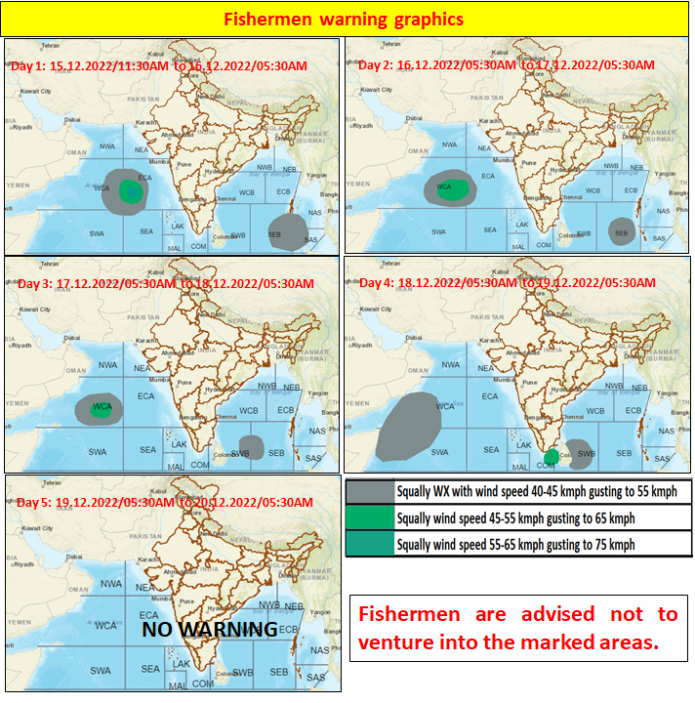

FOR HEAD.

